# Research

Contents

Research 1

Drone research 2

Types of drones: 2

Multi-rotor drones 2

Fixed wing drones 2

Single rotor drones 3

Ethical use 3

Unethical use 3

# Drone research

## Types of drones:

### Multi-rotor drones

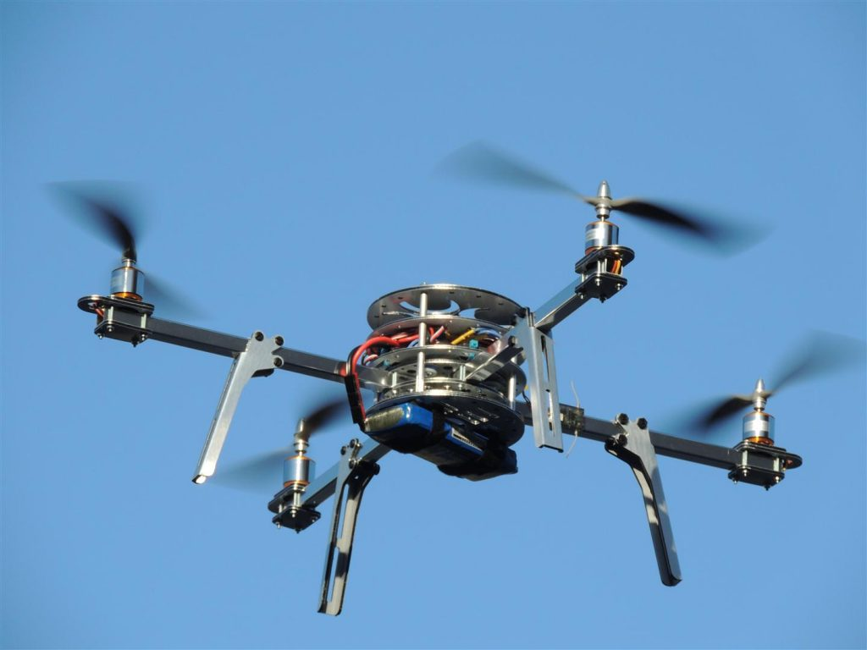

This type of drone is the most common type of drone used amongst consumers. There uses include aerial photography, aerial video surveillance and amateur drone racing as well as leisure flying.

* Tricopter – 3 rotors
* Quadcopter – 4 rotors (most common type)
* Hexacopter – 6 rotors
* Octocopter – 8 rotors

|  |  |
| --- | --- |
| Advantages | Disadvantages |
| Easy to manufacture | Limited flight time |
| Cheaper price | Limited endurance & speed |
| Easy to use | Uses large portion of energy to hover/stabilise in the air |

### Fixed wing drones

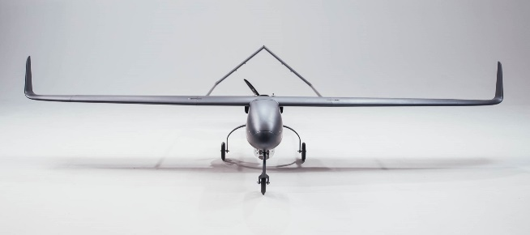

Fixed wing drones are designed similar to how airplanes are designed, and they do not need to utilise energy to remain in the air instead it glides.

|  |  |
| --- | --- |
| Advantages | Disadvantages |
| Can fly for a couple hours although the gas engine powered version can fly longer | Cannot hover in the air |
| Good for long distance flying | Cannot be used for aerial photography |
|  | High cost and requires skill training |
|  | Requires the use of a runway or catapult laucher |

### Single rotor drones

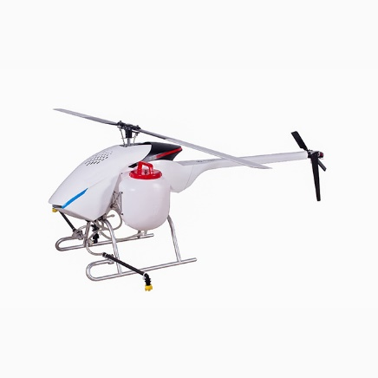

Similar design to a helicopter, has a big rotor and small rotor at the tail to control the heading

|  |  |
| --- | --- |
| Advantages | Disadvantages |
| Higher flying times | Costs |
| Does not need a runway or catapult launcher | Complexity & operational risks e.g. fatal injuries |
| Can hover | Special training required |

# Ethical use

Drones are often used for personal/company use. Sometimes a company may use drones to gain a bird’s eye view of an area of operation so they can monitor an area of operation e.g. solar panel farms, mining operations.

Drones are used sometimes when manned aircraft cannot be used due to many factors such as air traffic, potential danger for a manned pilot. Therefore, a drone can be used instead as drones are smaller and cheap to replace and maintain compared to a manned aircraft pilot.

# Unethical use

There has been reports made of unethical use of drones e.g. used to stalk/monitor people. A primary concern is safety as most drones fly at low attitude which can cause a danger to life if used in a populated area.

Military use of drones has been a topic such as the use of UAV’s as they have the potential to cause collateral damage and risk the potential of being hacked